**FIFA 18 - Analysis**

**Audience Persona** – Board (Board of directors of a football club who want to buy 11 players)

Let’s suppose out client wants to build a football team with a budget of 500M euros which would be capable of winning tournaments for the next five years. To make their selection process easier, we design visuals of diGerent stats to help them choose the players using details like overall rating, potential rating, and market value of each player from the FIFA 18 dataset. At first glance, it would seem ideal to recommend eleven players with similar market values. By doing so, we would create a team with players of the same ability regardless of their age and potential. This would not be ideal in the long run as we would be neglecting players who can potentially grow multiple ratings.

Another strategy would be to go for players with higher potentials regardless of rating. This would create an inexperienced team as these players are usually young and have low ratings. Bringing these players together wouldn’t be ideal for their growth.

Given these setbacks, we are required to suggest players that have high potential as well as experience. This approach enables us to build a team that can be successful in the long run.

# DASHBOARD

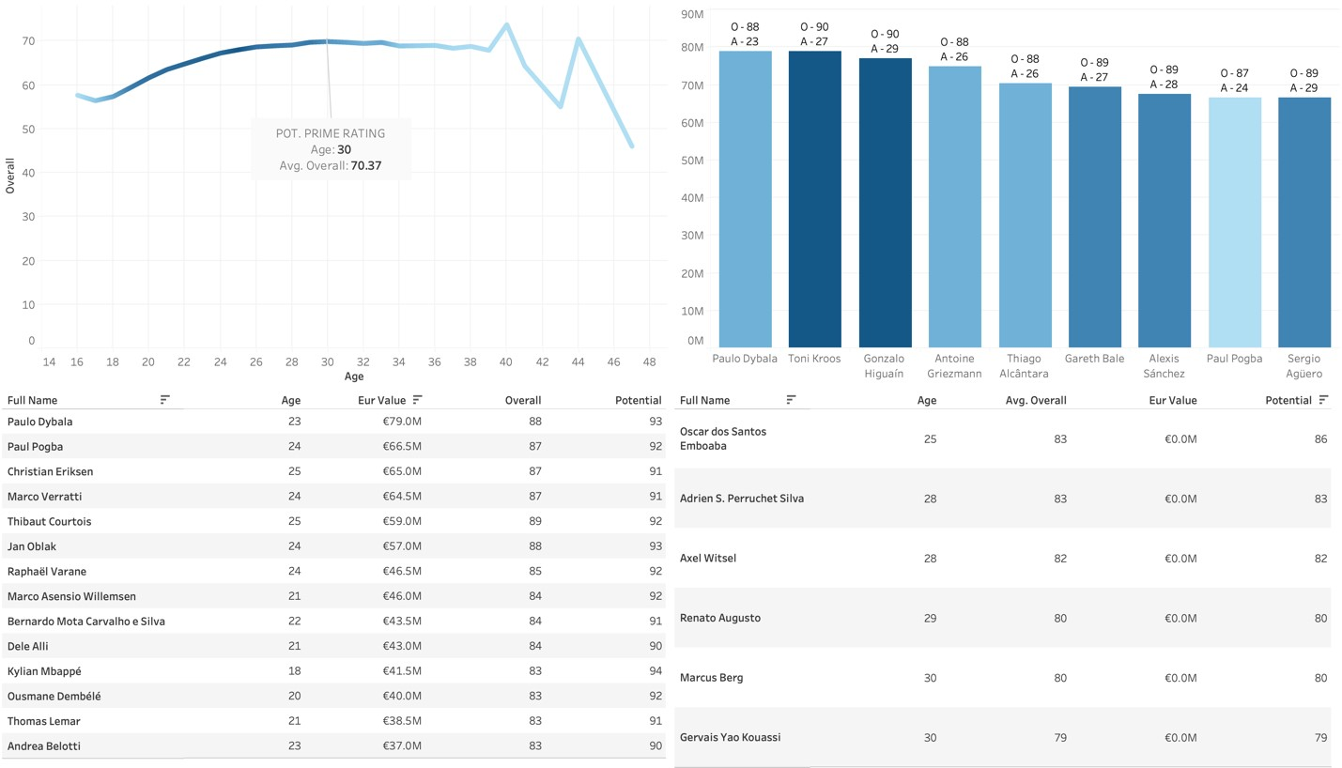

1. Average Overall – Age

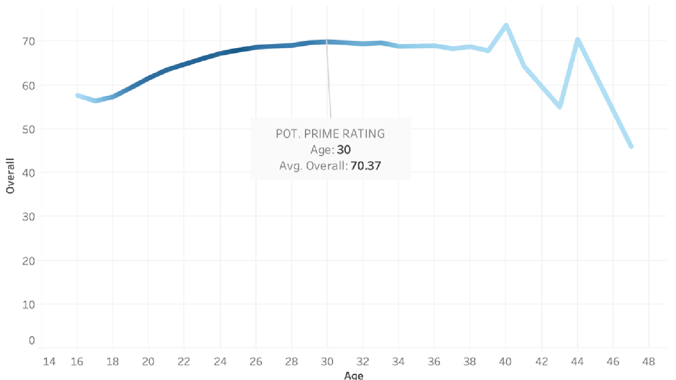

We can use this plot to analyze a player’s performance during diGerent points in their career. The darker shade of blue indicates the high number of instances. In this plot, we can see that the players of age 30 have the highest rating (even though the peak is 40, there are only four players with avg rating 40, not enough to suggest it is the peak). This implies that any randomly chosen player would perform the best when they are 30 years old. We can also notice an upward trend in overall rating until 33, indicating that players younger than 33 are capable of reaching their potential rating. This upward trend is more evident in the 20-25 range suggesting that 20–25-year-old players reach their potential sooner.

1. Market Value bar chart

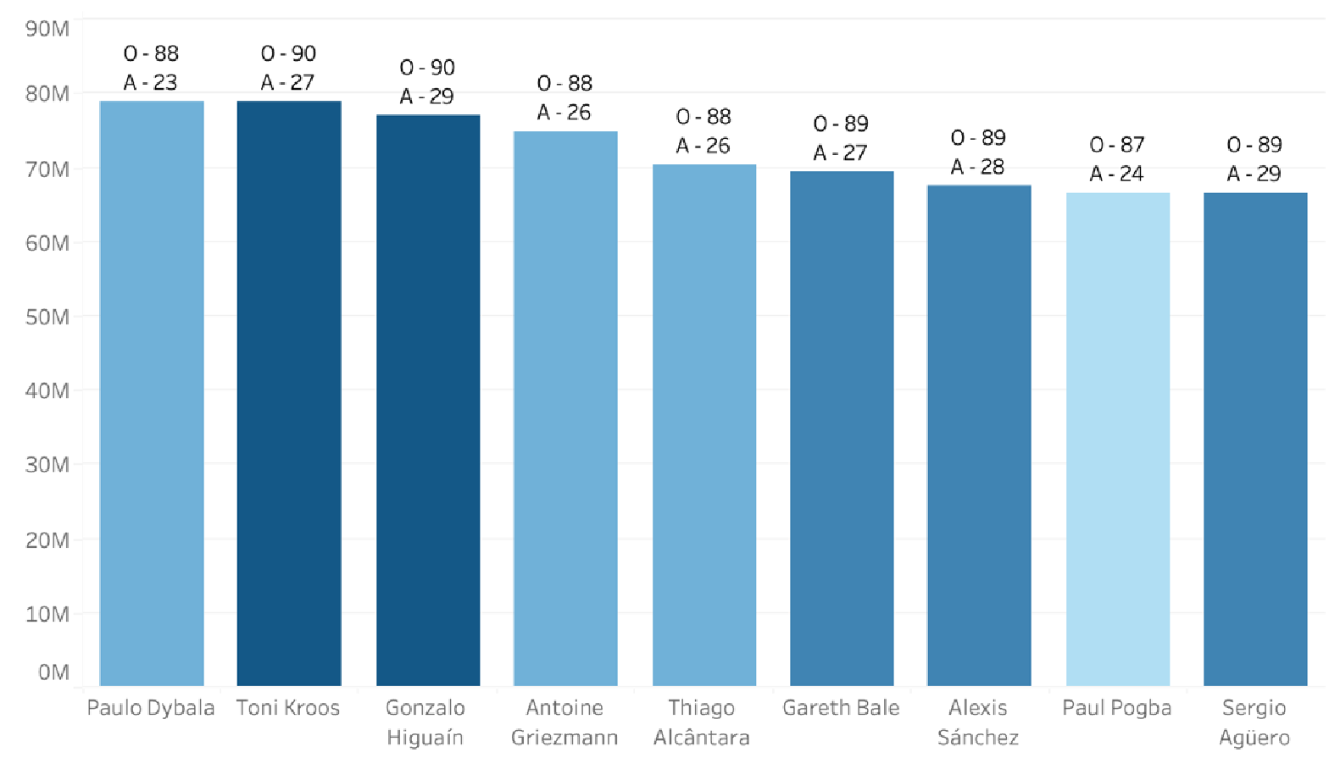

This plot shows the best players under the age of 33 with a market value between 60M and 80M in decreasing order of their values. The darker shades of blue indicate higher overall rating. Keeping our budget constraints in mind, we would be looking at the darker bars in the right end of this plot. It is crucial to determine which attributes we prioritize. If we want players with high ratings, we should choose options like Sergio Aguero, Gonzalo Higuain and Toni Kroos as they have the highest ratings. If we focus more on youth development, Paul Pogba, Thiago Alcantara and Paulo Dybala would be the ideal choices as they are the youngest players.

1. Highest Potential Table

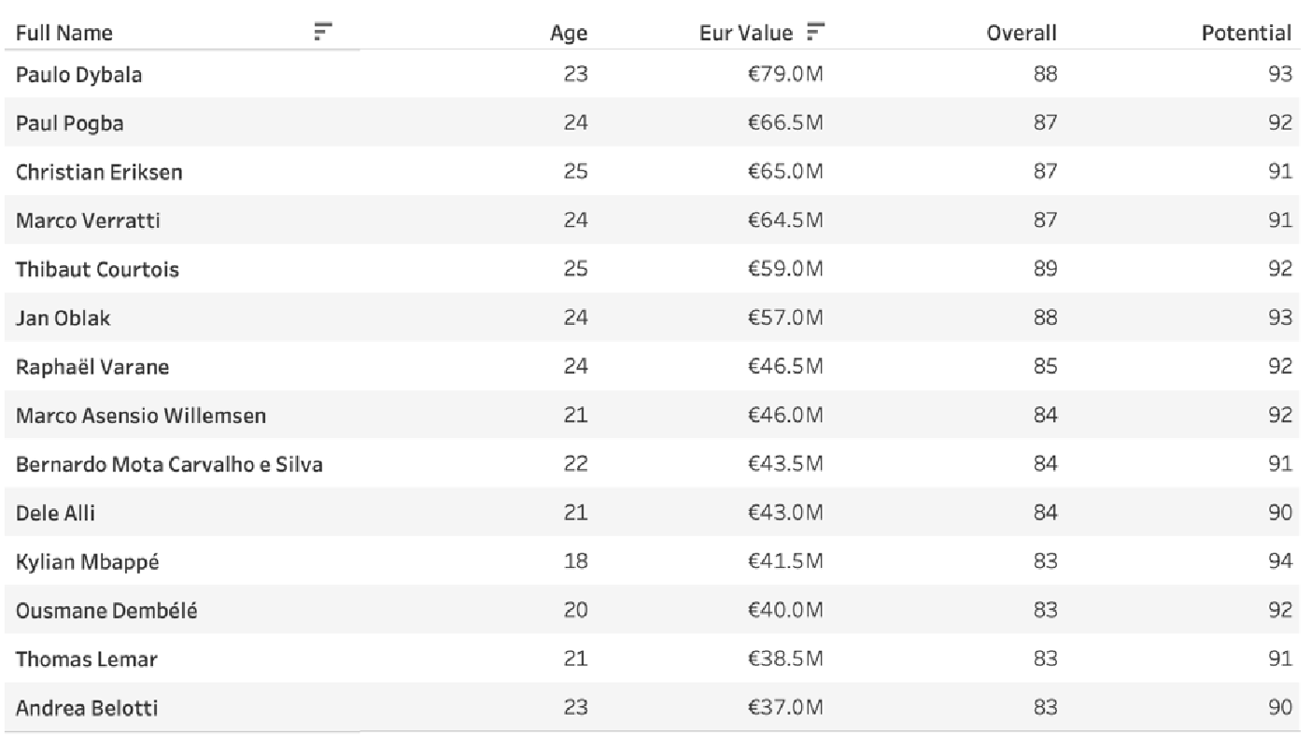

This table shows us players with the highest potential ratings under the age of 25 valued under 80M sorted in decreasing order of their values. We use these value thresholds based on the conclusions from the first plot. If we were to build a sustainable team, we would pick majority of our players from this plot as they are young and have high overall ratings and potential. Kylian Mbappe would be a fantastic option as he has the highest potential rating with a decent overall and is relatively cheap. Christian Eriksen, Marco Verrarti, Jan Oblak and Thibaut Courtois would be ideal options as they have high ratings an potential.

4. Free Agents

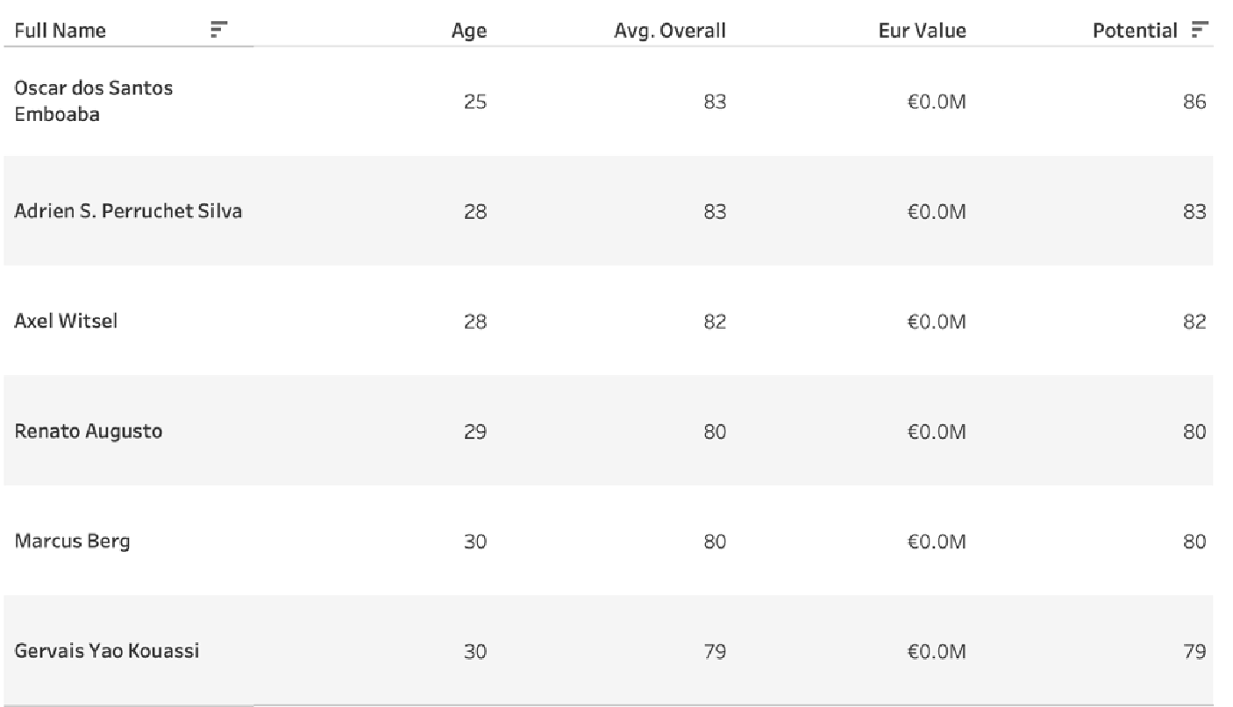

The final table shows us the highest rated players who cost nothing. Oscar dos Santos Emboaba would be a decent purchase.

Finally, from these visuals and the budget allocated, we can buy the following players.

|  |  |  |
| --- | --- | --- |
| Name | Value | Overall Rating |
| Sergio Aguero | 66.5M | 89 |
| Paulo Dybala | 79.0M | 88 |
| Jan Oblak | 57.0M | 88 |
| Raphael Varane | 46.5M | 85 |
| Marco Asensio | 46.0M | 84 |
| Bernardo Silva | 43.5M | 84 |
| Kylian Mbappe | 41.5M | 83 |
| Ousmane Dembele | 40.0M | 83 |
| Thomas Lemar | 38.5M | 83 |
| Andrea Belotti | 37.0M | 83 |
| Oscar | 0.0M | 83 |

The total comes up to 495.5M euros.

Additional Visualizations

5. Best Players (best options if there were no budget constraints)

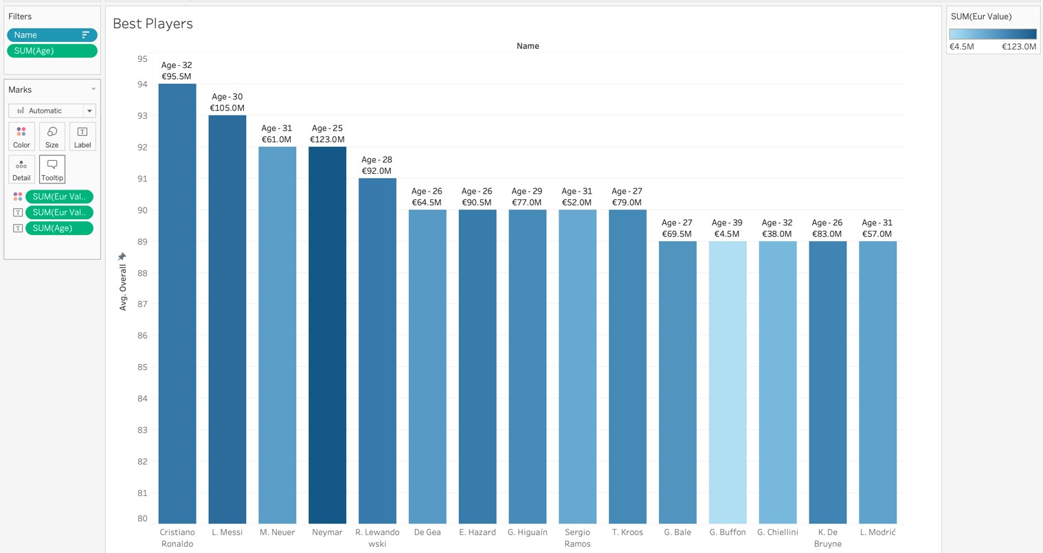

6.Best Young Players

